Part I: Deep Origins

**Biological Vision**

The Evolution of Vision:

Vision has been a crucial factor in the evolution of life on earth. About five hundred fifty million years ago, in the prehistoric Cambrian period, the number of species on the planet began to surge. Our understanding today of the causal factors behind this surge in biodiversity are still evolving but current research (Andrew Parker’s “Light Switch Theory” in particular) indicates that a critical factor was the development of light detectors in animals like the trilobite (a small marine animal related to modern crabs). This development of light detectors was in turn triggered by visibility changes in the earth’s atmosphere.

Now, commonsense tells us that, given the presence of light, a visual system (even a simple one) would enable a powerful set of survival capabilities. With vision, animals could spot food, friends, foes, and obstacles at much longer distances. This was an enormous advantage. Other senses such as smell, also enable animals to detect these as well. But the accuracy, distance and “light-speed” immediacy of vision, are unmatched! So the fact that the trilobite could see set off an evolutionary “arms race”; one that, according to some scientists, triggered the Cambrian explosion as the trilobite’s prey, as well as its predators, had to evolve rapidly just to survive!

*Here is a graph of time against genera (categories of related species). Notice in the graph that, the number of species on our planet began to increase rapidly 550 million years ago i.e. during the prehistoric Cambrian period. The horizontal axis represents the period in millions of years and ranges from 550 million years before the current era to the present time. The vertical axis represents the genera from 0 to 5, in terms of thousands of genera. This single curve-graph succinctly shows the rise of species from the pre-historic Cambrian era until today. There is a small increase from the Cambrian era that remains constant for a while, when it attains one thousand genera. At this point, after a subtle dip, a gradual increase is noticed, reaching around 4000 genera in the present generation.*

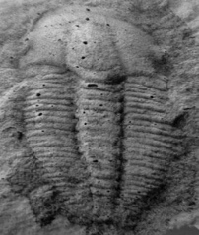 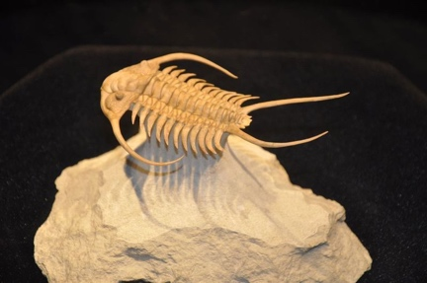

*Trilobite Fossils. The fossil on the left is from Himachal Pradesh!*

But the recognition of the impact of light and vision on evolution and biodiversity was an idea that took its time to arrive.

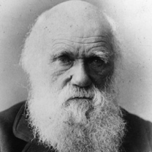 Charles Darwin, best known for his contributions to the science of

evolution and one of the most influential figures in human history, had a hard time comprehending how life diversity could, so suddenly, burst into evolution during the Cambrian period. After all, natural selection emphasized *small gradual changes over a long period of time, not rapid bursts*. Hence, in his lifetime, he could not adequately explain the Cambrian explosion from a classic evolutionary theory perspective. But fossil records clearly show that complex multi-cellular organisms existed in the Precambrian periods. Trilobites and other famous Cambrian fossils were preceded by a number of creatures that swarmed in the prehistoric seas. So, his basic evolutionary hypothesis was proven via scientific evidence in posterity, which is a tribute to the veracity of his hypothesis. However, what was not completely clear was why there was such an explosion.

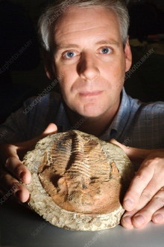 Andrew Parker, a Zoologist from Oxford, in his Light Switch Theory, states that *vision* was the key to unlocking the Cambrian explosion puzzle. He does a good job of bridging the gap in our understanding of the Cambrian period in his book “In the Blink of an Eye: How Vision Sparked the Big Bang of Evolution”. Here’s how he addresses Darwin’s issues with the implausible pace of biodiversity during the Cambrian period:

*“Revolutions in evolutionary theory have occurred since Darwin’s time. We know now that the history of life on Earth has been dominated by long periods of gradual evolution— ‘micro-evolution’ —or even a complete standstill. But these periods ended abruptly and were replaced by ‘macro-evolution’—short but prolific bursts in evolutionary activity, hence supporting a so-called ‘punctuated equilibrium’ model for evolutionary history. Darwin and others of his time cannot be blamed for overlooking macro-evolution because its discovery was a consequence of twentieth-century fossil finds and the development of modern biochemical techniques.”*

In fact, his perspectives on the Cambrian period itself is a bit different from other scientists:

*” [….] the Cambrian period is not properly described simply by its great life diversity. This flippant approach to the most dramatic event in the history of life is misleading in the extreme, and, has led to a number of false explanations for the cause of the event. […] The Cambrian explosion is the evolutionary episode in which under remorseless selection pressure* ***all*** *animal phyla attained complex external forms. In other words,* ***it is the event during which animal phyla changed from all looking the same to looking different****. […] By external parts of animals, I refer to the materials, the colors and the shapes of the outer layers. These have a closer association with the environment than do with internal organizations. […] Think of the protective spines, swimming paddles, burrowing shapes, grasping arms, eyes and colors.”*

Parker’s Light Switch Theory postulates that once the atmospheric changes that occurred around the Cambrian increased the amount of light reaching the Earth, the survival benefits of vision became clear. Therefore, eyes emerged rapidly, and nervous systems developed as part of the co-evolution of the eye and the brain. Vision accelerated predation as, with vision, predators were able to see, pursue, and capture prey better.  Hard parts of the body, such as teeth and jaws, emerged to support predation. In evolutionary prey response, *protective* hard parts such as shells evolved to protect smaller animals from the predators. Newer predatory behavior and countermeasures evolve. For example, with the arrival of vision for predators, prey developed camouflage. And the process continued. All animals *had* to adapt to the presence of eyes not only in terms of their [the animals’] color, but all factors affecting an animal’s appearance on a retina. These factors include shape and behavior. Species that didn't adapt died out (predator and prey alike).

Andrew Parker’s Light Switch Theory is controversial among biologists, but it is cited with approval by many scientists not only because it possibly explains the reason for the Cambrian explosion, but also *sets apart the* *eyes and vision as one of the driving forces of natural selection and evolution*. That is a radical but plausible viewpoint. Parker’s theory also suggests an evolutionary reason for the *overwhelming supremacy of the human vision over the other senses*, and in general of the gradual *natural predominance of vision over olfaction in primates*. The importance of vision in humanity’s evolutionary journey and the fact that so much of our brain is involved in visual processing, is also the reason why AI has and continues to be obsessed with Machine Vision!

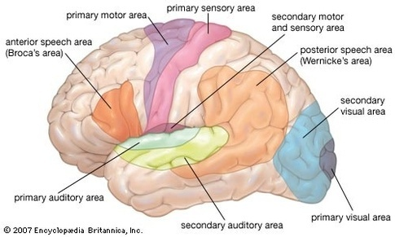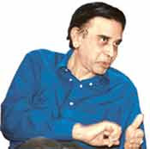 *Talking about the dominance of vision over olfaction,* *roughly, 2/3 (60%+) of the brain is "involved" in vision, the breakdown being 20% dedicated to "visual-only" function, the other 40% doing vision+touch, or vision+motor, or vision+attention, or vision+spatial navigation, or vision+meaning, etc. There’s a smooth gradation from areas fully specialized to one thing to areas involved in many things. The parts of the brain that process smell are physically underneath the parts that process vision, and are not visible!*

Today, we know for a fact that in modern mammals, a large proportion of the cerebral cortex (the outer gray matter of the brain) is involved in visual perception. In the half-billion years since trilobites developed rudimentary vision, the complexity of the sense has increased considerably. So has our understanding of it. But just as with other important ideas, our understanding of the process of perception by our brain has had a long and slow dawning through time.

**Evolution of our perspectives on vision through Ancient and Medieval periods**

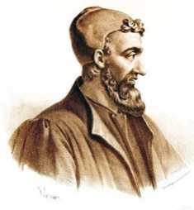 Galen (c.130-200) was a physician, anatomist, writer and philosopher who became the most famous physician in the Roman Empire *(he was the personal physician of the emperor Marcus Aurelius).* His theories dominated European medicine for *1,500 years*. Galen, who studied in Alexandria (where bodily dissection was allowed), introduced the concept of *visual disparity* i.e. the two eyes see the same object differently, in the 10th chapter of his work entitled *On the Use of the Parts of the Human Body*. The story goes that he had intended to omit that chapter as it would contain too many difficult mathematical formulae, but then had a dream which persuaded him to keep it in. From Galen we all derive our use of many anatomical terms for the parts of the eye such as the retina or the crystalline lens.

Avicenna (Ibn Sina) (980-1037), a visionary Persian polymath, was the first to overturn the, then common, idea that *the* *eye* emitted rays that bounced off an object being viewed, thus triggering perception. Avicenna determined that actually, light rays go into the eye and that the lens of the eye played in a role in the visual process. William Osler, one of the founding fathers of modern medicine and a founder of Johns Hopkins University described Avicenna's book as the most important work ever. It was used in medical schools beyond the late 14th century!

*'it is not the ray that leaves the eye and meets the object that gives rise to vision, but rather the form of perceived object passes* *into the eye and is transmuted by the transparent body, that is, the lens'.*

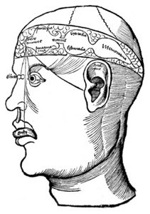In 1503 Gregor Reisch, a well-known humanist, published *Margarita philosophica*, a brief encyclopedia of knowledge, intended as a textbook for young students. In it we find mention of Reisch's cell theory which (though anatomically inaccurate) recognized that a mechanistic process was at work inside our brain. Reisch suggested that images passed through a *hierarchical chain of cells inside the brain*. You can see this chain in the diagram to the left. The eyes input information to the first set of cells, the “sensus commensis”. This information was then relayed to the second and third set of cells for *progressively higher thought processing*. For its time, this was extremely sophisticated thinking about the process of vision and cognition.

**Da Vinci and the Early Modern Period**

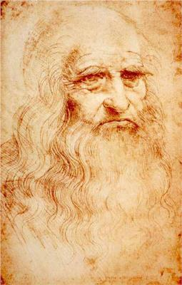Leonardo da Vinci, the great Italian polymath, had a spirit of scientific inquiry and a mechanical inventiveness that were centuries ahead of their time. The unique fame that Leonardo had rests largely on his ability to pursue his unlimited desire for knowledge despite setbacks. It guided all his thinking and behavior. An artist by [disposition](https://www.merriam-webster.com/dictionary/disposition) and endowment, he considered his *eyes* to be his main avenue to knowledge; to Leonardo, sight was man’s highest sense because it alone conveyed the facts of experience immediately, correctly, and with certainty. Hence, every phenomenon perceived became an object of knowledge, and *saper vedere* (“knowing how to see”) became the great theme of his studies.

Leonardo studied vision extensively and was the first to propose the theory that *the inverted retinal image was actually re-inverted inside the brain*. Below, you can see two of Leonardo's drawings, dating from 1490 and 1506 respectively. The third image demonstrates his theory of the *re-inversion of an inverted retinal image*.

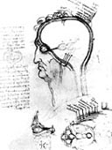

1490 Drawing by Da Vinci

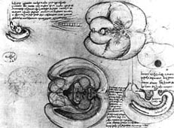

1506 Drawing by DaVinci

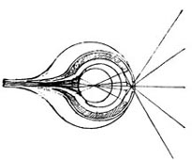

DaVinci’s Inverted retinal image

**The Seventeenth Century**

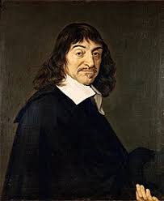Rene Descartes is considered the first modern philosopher and is famous for having made an important connection between geometry and algebra, which allowed for the solving of geometrical problems by way of algebraic equations. He is also famous for having promoted a new conception of matter, which allowed for the accounting of (bio)physical phenomena by way of mechanical explanations. He is most famous for having written a relatively short work, *Meditationes de Prima Philosophia* (*Meditations On First Philosophy*), published in 1641, in which he provides a philosophical groundwork for the possibility of the sciences.

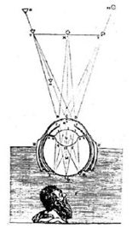 As part of a series of experiments on the mechanics of biological vision, Descartes stripped the sclera and choroid off the eye of an ox and performed a projection experiment onto a piece of paper and proved that the retina initially actually sees an *inverted image.* He concluded it was indeed the brain that did the second inversion. The diagram on the left, from Descartes' *La Dioptrique* (1637), shows Descartes observing the retinal image.

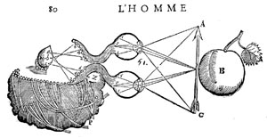Later, in his *Traité de l'Homme* (finished by 1648 but not published until 1664, after his death) Descartes thought of the brain as a machine with fibers running from the eyes like optical cables. These formed a rudimentary visual pathway. The inner soul within the brain then viewed the image transferred to it along the pathway by vibrational forces. You can see the two separate vibrating paths in his drawing on the left which shows the eyes looking at an apple and the image travelling to an artist's representation of the soul.

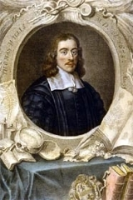 That same year of 1664 Thomas Willis (1621 – 1675), an anatomist often referred to as the 'Father of Neurology', investigated the brains of different animals. The illustrations of his findings, published as the *Cerebri Anatome*, were drawn by Sir Christopher Wren, the architect.

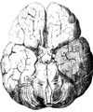Willis rejected the idea that the actual substance of the brain (or some fluid within it) performed its functions. He concluded that the performance of the human visual function was closely related to an *extensive cerebral cortex* and that was why man had better memory than many animals. In fact, the ophthalmic branch of the fifth nerve is called Willis' Nerve.

In 1682 William Briggs (1650-1704) developed on Willis’s when he described optic pathways more thoroughly and hinted at the idea that the retinal nerve fibers from the two eyes may cross over at some point behind the eye. (Newton's *Opticks*, already written but not yet published, would confirm this in 1705). Briggs recognized that fusion occurred in the optic tract, not in the “soul”.

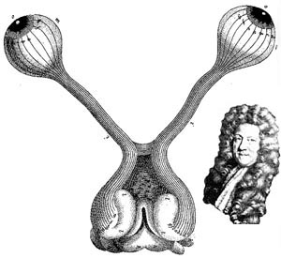Diagram of the visual pathway according to William Briggs (1682), bearing the first hint of an understanding of the decussation of fibers at the chiasma  
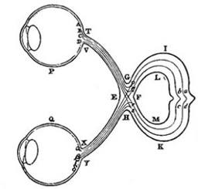Diagram of the visual pathway according to Isaac Newton, produced in 1682 but not publicized at the time

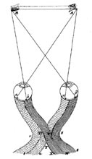

**The Eighteenth and Nineteenth Centuries**

In 1738 John Taylor produced an improved and very influential pathway diagram. The crossover of the fibers was now accepted. But the nineteenth century fascination with phrenology proved a false dawn for vision scientists. Amidst the largely discredited pseudo-science of men such as Franz Gall (1757-1828), there was a recognition that specific functions related to localized parts of the brain's cortex (neural localization). Unfortunately, this important point was thrown out with the bath water...a *setback for our subject that lasted well into the next century*. Here is a comparison between a standard phrenological head and the head of Gall himself. Beside that we have superimposed a nineteenth century image of the brain showing the visual region marked towards the back of the head.

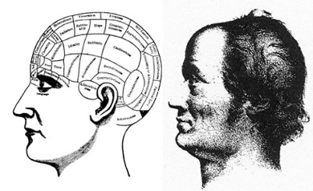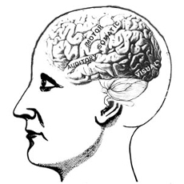

**The Twentieth Century**

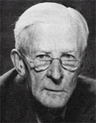 Lord Edgar Adrian (1889-1977) recorded sensory nerve impulses from the end of the 1920s and so gave us the notion of a pulse code with a frequency of transmission to the brain that can be measured.

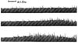 Here are his recordings from the sensory nerves of a cat's toe (1929).

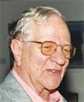

Horace Barlow: In the second half of the 20th century Horace Barlow FRS (b.1921) proved a key figure in interpreting how the eye detects distance in objects. This was research into stereoscopic vision, a phenomenon first described by Sir Charles Wheatstone (1802-75). In the 1950s Barlow also studied light and dark 'adaptation'. He described how certain animals learn from experience how to react to 'trigger factors' such a movement, light and outlines.

**Enter Hubel and Wiesel** 

Then, in the late 1950s, physiologists David Hubel and Torsten Wiesel (Figure 1.3) began carrying out research on how visual information is processed in the mammalian cerebral cortex (reference 3). Eventually this resulted in major progress in our understanding of the brain, significant advances in the treatment of childhood cataracts, and informing current research to enable computers to process images more like the human mind. In 1981, they were awarded a Nobel Prize in Physiology or Medicine for their groundbreaking work. (reference 4)

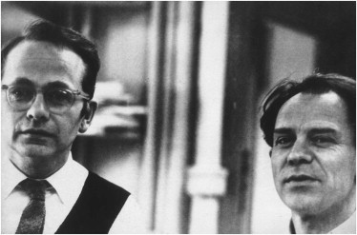

*Nobel Prize-winning neurophysiologists David Hubel (left) and Torsten Wiesel*

Hubel and Wiesel conducted their research by showing images to anesthetized cats while simultaneously recording the activity of individual neurons from the primary visual cortex, the first part of the cerebral cortex to receive visual input from the eyes.

*Depicted in this figure is a primary visual cortex neuron being activated by the straight edge of a slide (shown here as a light bulb turned on to represent neuron activation). Hubel and Wiesel used a light projector to present slides to cats under anesthesia while they recorded the activity of neurons in the cats’ primary visual cortex. In the experiments, electrical recording equipment was implanted (yes, I know! Things are quite different now thanks to technology!) within the cat’s skull. (reference 2).*

In fact, the story of Torsten and Hubel’s journey to discovery of neuronal activation is so unique that Wiesel and Hubel were actually selected as the second winners of the *Golden Goose Award* in 2015 which honors researchers whose (federally funded) work *may have seemed odd or obscure when it was first conducted but has resulted in significant benefits to society!* The story goes that their extraordinary research really took off with a simple, fortuitous accident with the kittens in their lab: *somebody pushed a glass slide too far on an overhead projector!*

The two researchers began their research with what was known i.e. light stimulates light-sensing receptor cells in the retina of the eye, and different receptor cells respond to stimuli in different parts of the retina's visual field.

But Hubel and Wiesel were studying *nerve cells, or neurons*, in higher-functioning areas of the brain which had not previously studied. They found these cells frustratingly unresponsive to even simple stimuli—small spots of light or a black dot on a clear glass slide projected onto a screen.

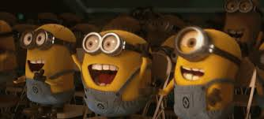

As they were adjusting their equipment, a single line moved across the screen at *a* *particular angle*—and that caused one cat's neuron to fire. The scientists then proceeded to study that single neuron for *nine* consecutive hours. Over the course of the next several months, Hubel and Wiesel made the first crucial steps forward in our understanding of visual processing. They found that particular neurons in the visual cortexes of cats and monkeys—the areas in their brains responsible for processing visual information—did *not* respond to simple points of light, but rather to *lines*, and in particular, lines and contours with specific orientations. Some neurons responded to horizontal lines, others to vertical, and still others to orientations in between. In addition, they found neurons responding to signals from both eyes, but usually one or the other would dominate.

*A simple cell in the primary visual cortex of a cat fires at different rates, depending on the orientation of a line shown to the cat. The orientation of the line is provided in the left-hand column, while the right-hand column shows the firing (electrical activity) in the cell over time (one second). A vertical line (in the fifth row from the top) causes the most electrical activity for this particular simple cell. Lines slightly off vertical (in the intermediate rows) cause less activity for the cell, while lines approaching horizontal (in the topmost and bottommost rows) cause little to no activity.*



*This figure shows how, via many hierarchically organized layers of neurons feeding information into increasingly higher-order neurons, gradually more complex visual stimuli can be represented by the brain! Here, you can see:*

1. *The eyes are focused on an image of a mouse’s head*
2. *Photons of light stimulate neurons located in the retina of each eye, and this raw visual information is transmitted from the eyes to the primary visual cortex of the brain*
3. *The first layer of primary visual cortex neurons to receive this input— Hubel and Wiesel’s* ***simple cells****— are specialized to detect edges (straight lines) at specific orientations. There would be many thousands of such neurons; for simplicity, we’re only showing four in the figure*
4. *These simple neurons relay information about the presence or absence of lines at particular orientations to a subsequent layer of complex cells*
5. *The complex cells assimilate and recombine the information, enabling the representation of more complex visual stimuli such as the curvature of the mouse’s head*
6. *As information is passed through several subsequent layers, representations of visual stimuli incrementally become more complex and more abstract.*
7. *As depicted by the far-right layer of neurons, following many layers of such hierarchical processing (we use the arrow with dashed lines to imply that many more layers of processing are not being shown), the brain is ultimately able to represent visual concepts as abstract as a mouse, a cat, a bird, or a dog.*
8. *Hubel, D. H., & Wiesel, T. N. (1959). Receptive fields of single neurons in the cat’s striate cortex. The Journal of Physiology, 148, 574– 91. 4. The 1981 Nobel Prize in Physiology or Medicine, shared with American neurobiologist Roger Sperry.*

Over subsequent years, Hubel and Wiesel refined their understanding, mapping the visual centers of their feline and primate subjects with increasing precision. They found the visual cortex consisted of narrow columns of cells organized by eye preference and response to orientation, which they termed "ocular dominance columns" and "orientation columns." Combined these columns of cells formed an elegantly organized *functional map of neurons* that could process the complex input arriving from both of the animal's eyes.

Their inspiring work on cats’ visual cortex ultimately led to their winning the *1981 Nobel Prize in physiology or medicine*, which they shared with CalTech's Roger Sperry. The Nobel committee singled out their research for solving "one of the most well-guarded secrets of the brain: the way by which its cells decode the message which the brain receives from the eye."

Interestingly, soon after moving from Johns Hopkins to Harvard, with their newfound understanding of the brain's organizational structure in hand, Hubel and Wiesel sought to address a perennial question in biology namely, *nature or nurture*? To answer that question, they decided to tackle this problem from a vision perspective. Hubel and Wiesel began by studying the brains of newborn animals with *no visual experience*. Interestingly, they found that their feline and primate subjects were born with that *elegant functional map already in place in their visual cortices*. They found neurons that would respond onlyto oriented stimuli and that responded to stimulation of both eyes. They concluded that *nature* provides the neural connections necessary for these two basic response properties.

So what then is the role of *nurture* for the normal development of the brain? Was vision fixed at birth? It was well known, from medical clinics, that children born with cataracts suffer from severe visual deficits *even after their opaque lens is removed a few years after birth*. If vision was prewired at birth, with the physical blockage gone, why would this be the case? After all, Hubel and Wiesel had shown that the necessary *neural connections* should be present at birth.

The researchers decided to address this question by studying the impact of raising kittens and monkeys from birth with *one eye covered and the other left open*. They found that the animal *behaved as if it was blind in the previously covered eye*, just like in a child after cataract surgery. The cause of this loss of vision turned out to be that *neurons in the visual cortex no longer responded to stimulation of the deprived eye but only vigorously to the normal eye*. The elegant patterns of ocular dominance the researchers had seen in healthy animals disappeared, with the one dominant eye taking over almost the entire visual cortex.

Over a series of experiments, they demonstrated that the brain could literally wire or rewire itself in response to external input (or lack thereof)—a phenomenon known as neuroplasticity—and that this ability seemed to fade with age. Almost immediately, this realization of the importance of early stimulation to the wiring of the visual cortex translated from the lab to the clinic, where doctors were working to treat children born with cataracts and other eye impairments. With Hubel and Wiesel's new understanding, doctors began treating children *as early as possible*, with *much better* outcomes. Truly, Hubel and Wiesel were pioneers of the visual system, exploring the physiology behind visual perception in animals, thereby teaching us much about how our own minds work.

This is critical for today's computing technology. For some tasks, like computing and factoring large numbers, silicon has our "wetware" beat handily, but for the complex tasks like visual processing, machines are only beginning to catch up to the human brain. This is no small matter. Teaching computers how our minds work is big business. The "machine vision" market is projected to be tens of billions of dollars. Hubel and Wiesel's work is extremely relevant to this burgeoning field. From a slip of the hand while cats watched images on a screen, have come better treatments for childhood vision disorders and teaching computers how to process images—a powerful example of how science can advance society in the most unexpected ways.

 *Here are some interesting facts about the cerebral cortex:*

* *First, it is one of the more recent evolutionary developments of the brain, contributing to the complexity of mammal behavior relative to the behavior of older classes of animals like reptiles and amphibians.*
* *Second, while the brain is informally referred to as “gray matter” because the cerebral cortex is the brain’s external surface and this cortical tissue is gray in color, the bulk of the brain is in fact “white matter”.*
* *By and large, the white matter is responsible for carrying information over longer distances than the gray matter, so its neurons have a white-colored, fatty coating that hurries the pace of signal conduction. A coarse analogy could be to consider neurons in the white matter to act as “highways.”*
* *These high-speed motorways have a limited number of on-ramps or exits but can transport a signal from one part of the brain to another extremely fast. In contrast, the “local roads” of gray matter facilitate myriad opportunities for interconnection between neurons at the expense of speed.*
* *A gross generalization, therefore, is to consider the cerebral cortex— the gray matter— as the part of the brain where the most complex computations happen, affording the animals with the largest proportion of it— such as mammals, particularly the great apes like Homo sapiens— their complex behaviors.*

Today, through countless subsequent recordings from the cortical neurons of brain-surgery patients as well as noninvasive techniques like magnetic resonance imaging (MRI), neuroscientists have pieced together a fairly high-resolution map of regions that are specialized to process particular visual stimuli, such as color, motion, and faces.

*5. Especially useful is functional MRI (fMRI), which provides insight into which regions of the cerebral cortex are notably active or inactive when the brain is engaged in a particular activity.*

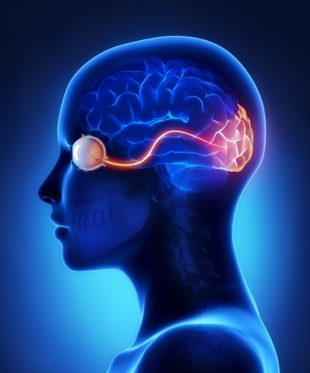 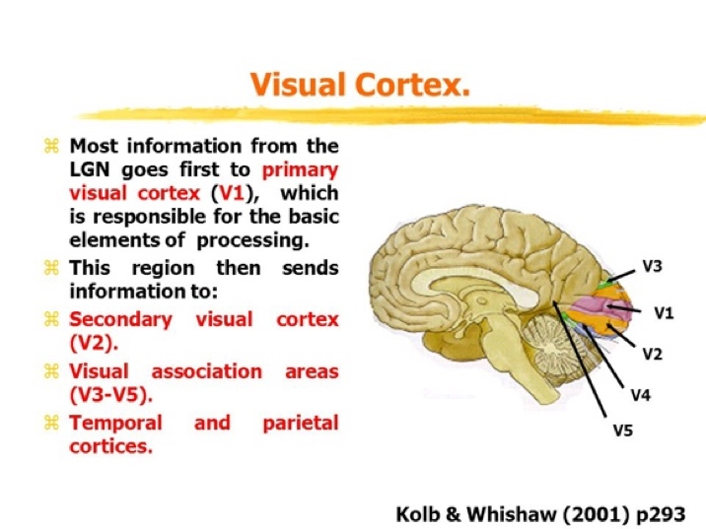

*The figure on the left shows how visual input travels from the eye to our visual cortex. The figure on the right shows the various regions of our visual cortex. The V1 region receives the input from the eyes and contains the simple cells that detect edge orientations. Through the recombination of information via myriad subsequent layers of neurons (including within the V2, V3, and V3a regions), increasingly abstract visual stimuli are represented. In the human brain (shown here), there are regions containing neurons with concentrations of specializations in, for example, the detection of color (V4), motion (V5), and people’s faces (fusiform face area).*